**ANNEX-1: SZUTEST LOGOS  
ANNEX-2: SZUTEST HALAL LOGOS  
ANNEX-3: SZUTEST TÜRKAK ACCREDITATION MARKS  
ANNEX-4: SZUTEST CERTIFICATION MARKS  
ANNEX-5: SZUTEST CERTIFICATION MARKS  
ANNEX-6: COMBINED MARK (IAF/IAS MLA COMBINED MARK) & DOCUMENT MARK  
ANNEX-7: DOCUMENT MARKS (TÜRKAK) - FOR MANAGEMENT SYSTEMS STANDARDS  
ANNEX-8: DOCUMENT MARKS (IAS) - FOR MANAGEMENT SYSTEMS STANDARDS  
ANNEX-9: DOCUMENT MARKS (TÜRKAK) - FOR PRODUCT CERTIFICATION  
(SZUTEST LOGO WITH TÜRKAK ACCREDITATION MARK)  
ANNEX-10: SZUTEST DOCUMENT MARKS (HAK) - FOR HALAL PRODUCT CERTIFICATION  
(SZUTEST HALAL LOGO WITH HAK ACCREDITATION MARK)  
ANNEX-11: COMBINATION OF NOTIFIED BODY IDENTIFICATION NUMBER AND SZUTEST LOGO  
ANNEX-12: USE OF CE MARK  
ANNEX-13: COMBINATION OF NOTIFIED BODY IDENTIFICATION NUMBER AND CE MARK  
ANNEX-14: VQA SZUTEST AUTHORIZATION MARK  
ANNEX-15: Ex MARK  
ANNEX-16: NOISE MARK  
ANNEX-17: IECEx LOGO  
ANNEX-18: GAC ACCREDITATION SYMBOL  
ANNEX-19: COMBINED MARK (IAF/TÜRKAK MLA COMBINED MARK)**

**ANNEX-1: SZUTEST LOGOS**  


**ANNEX-2: SZUTEST HALAL LOGOS**

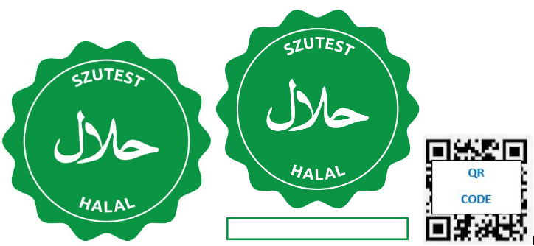  
Note: The unique number defined by SZUTEST for the relevant product must be used in the box under the Halal Brand.

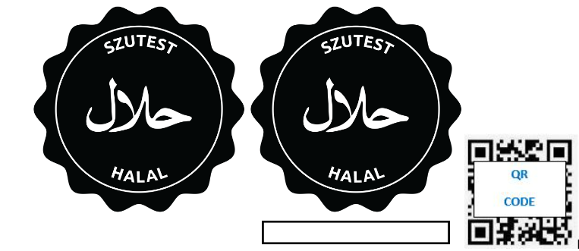  
Note: The unique number defined by SZUTEST for the relevant product must be used in the box under the Halal Brand.

**ANNEX-3: SZUTEST TÜRKAK ACCREDITATION MARKS**

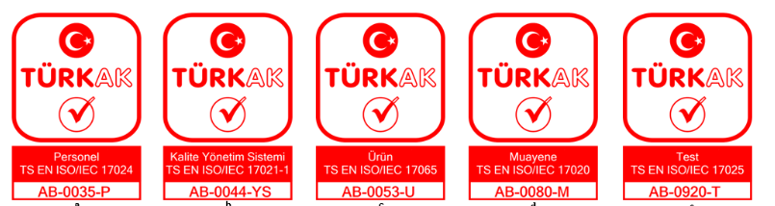

**ANNEX-4: SZUTEST CERTIFICATION MARKS**

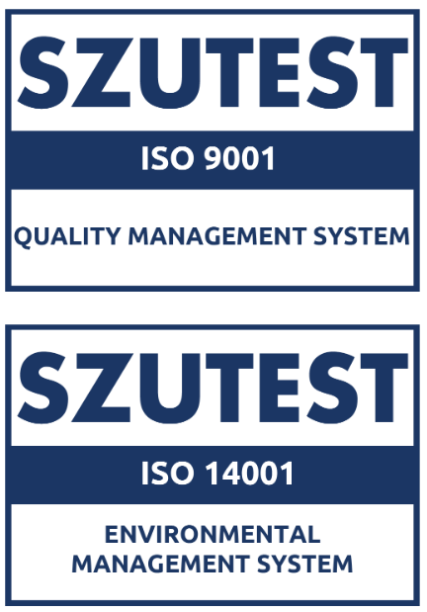  
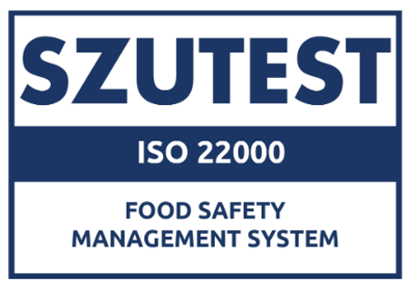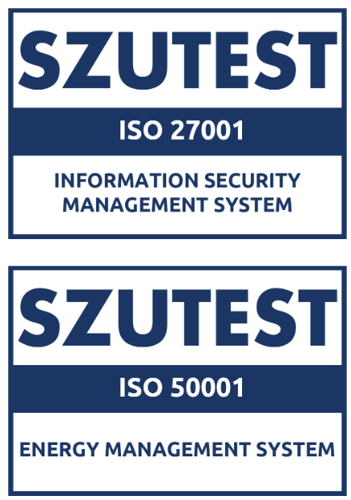  
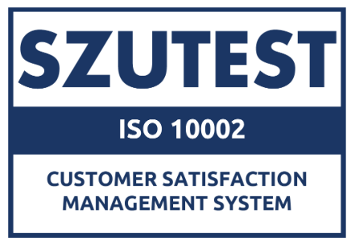  
  
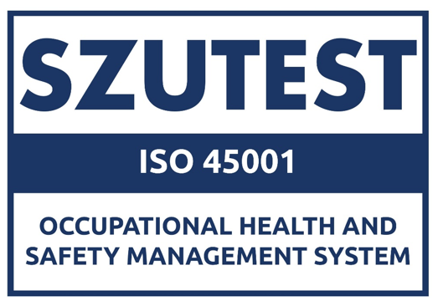

**ANNEX-5:** Given in the FR.290 SZUTEST Certification Marks Usage document. On dark backgrounds, versions of marks designed for dark backgrounds should be used. Marks with dark backgrounds can be accessed at **www.szutest.com.tr**.

**ANNEX-6: COMBINED MARK (IAF/IAS MLA COMBINED MARK) & DOCUMENT MARK**



**ANNEX-7: DOCUMENT MARKS (TÜRKAK) - FOR MANAGEMENT SYSTEMS STANDARDS**

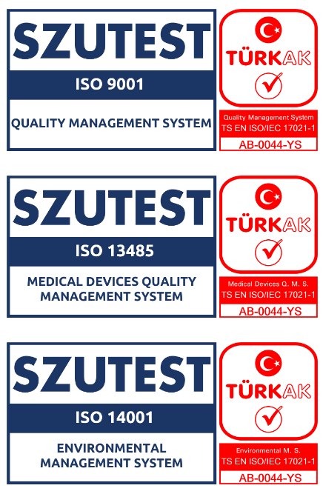





**ANNEX-8: DOCUMENT MARKS (IAS) - FOR MANAGEMENT SYSTEMS STANDARDS  
(SZUTEST CERTIFICATION MARK WITH IAS ACCREDITATION MARK)**

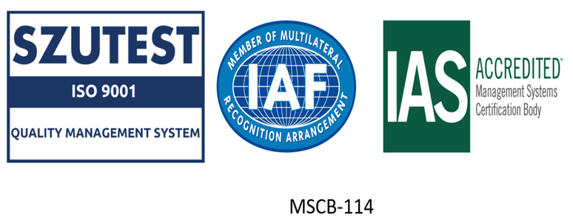

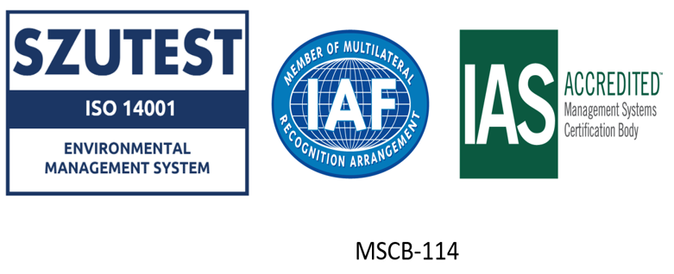

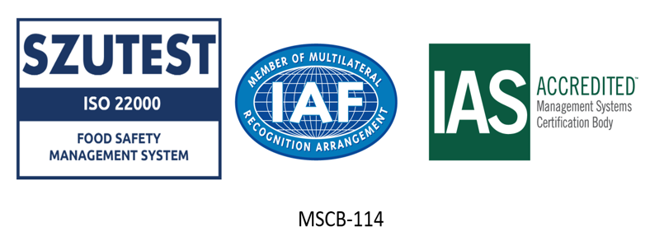

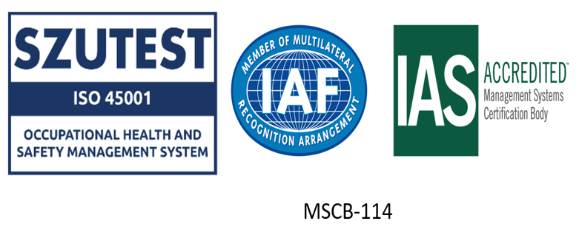

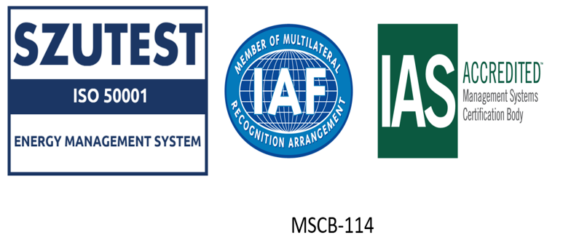

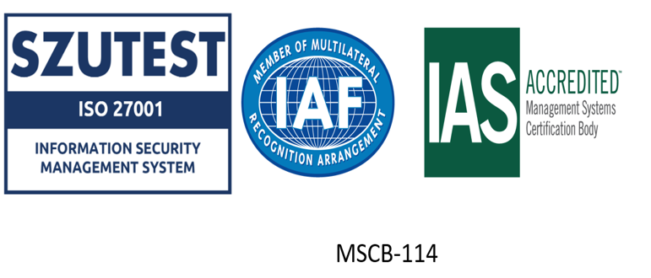

**ANNEX-9: DOCUMENT MARKS (TÜRKAK) - FOR PRODUCT CERTIFICATION  
(SZUTEST LOGO WITH TÜRKAK ACCREDITATION MARK)**

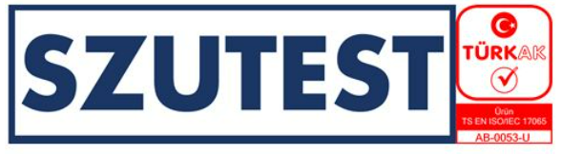

**ANNEX-10: SZUTEST DOCUMENT MARKS (HAK) - FOR HALAL PRODUCT CERTIFICATION  
(SZUTEST HALAL LOGO WITH HAK ACCREDITATION MARK)**

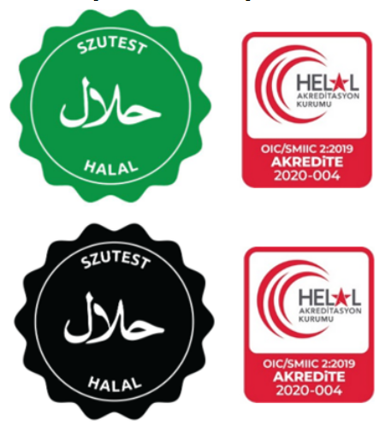

**ANNEX-11: COMBINATION OF NOTIFIED BODY IDENTIFICATION NUMBER AND SZUTEST LOGO**

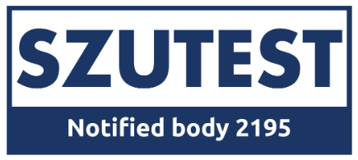

**ANNEX-12: USE OF CE MARK**  
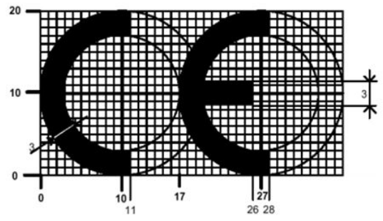

**ANNEX-13: COMBINATION OF NOTIFIED BODY IDENTIFICATION NUMBER AND CE MARK**

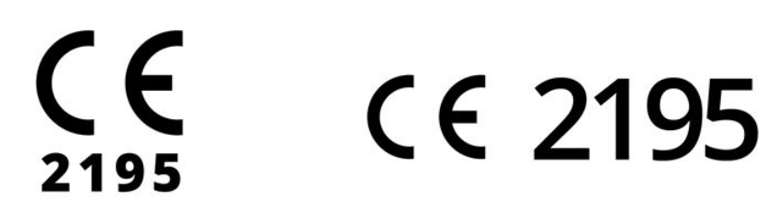

**ANNEX-14: VQA SZUTEST AUTHORIZATION MARK**

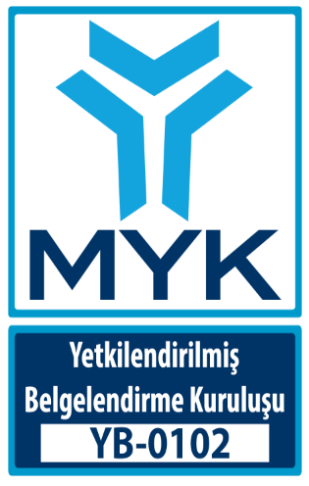

**ANNEX-15: Ex MARK**

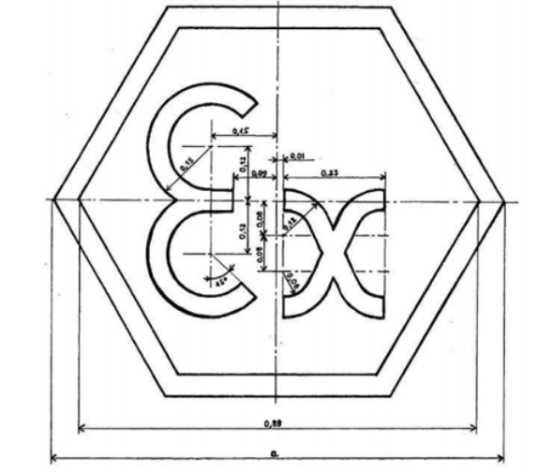

**ANNEX-16: NOISE MARK**  
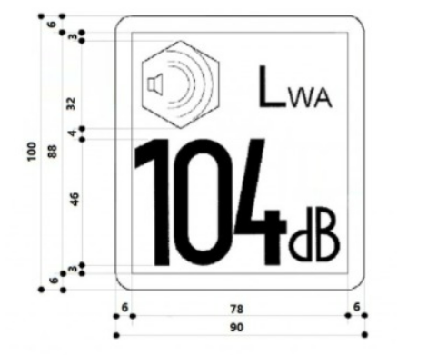  
  
  
**ANNEX-17: IECEx LOGO**  
  
  
**ANNEX-18: GAC ACCREDITATION SYMBOL**  
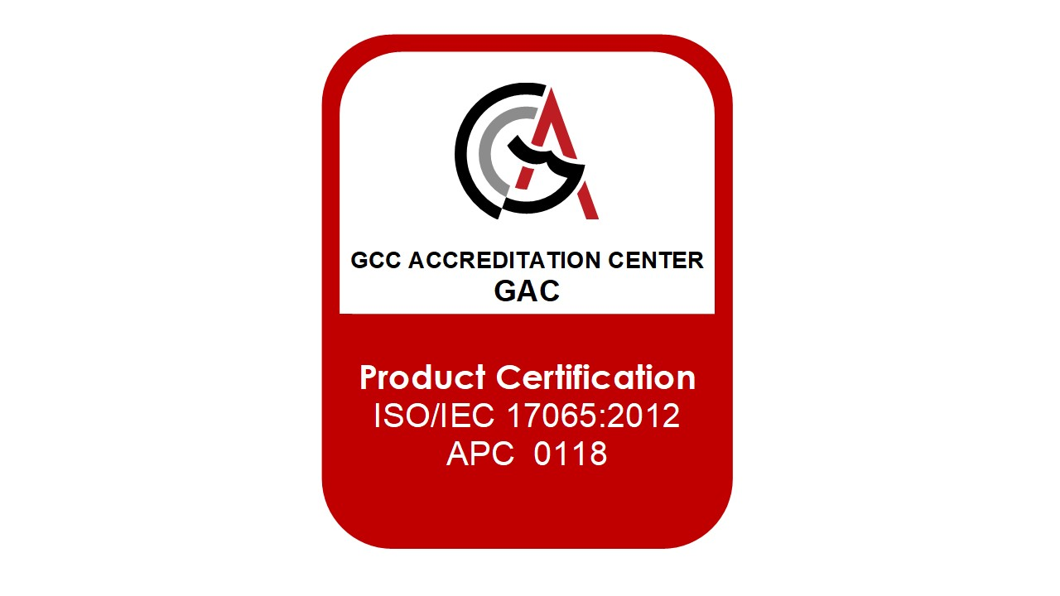

**ANNEX-19: COMBINED MARK (IAF/TÜRKAK MLA COMBINED MARK)**

